specifications
  - Archiving SOPL-LGa-0805 sales quotes by means of filter selection
Doc Version <X.Y>

Customer: | Soplar S.A.
Project: | Sales
proALPHA version: | 7.2d
proALPHA installation(s): | Soplar SA
GUI language: | German
Author: | Lars Garth
Created on: | Mar 13, 2023
Last Change On: | Mar 13, 2023
Contact person customer: | Christof Wüst

This document describes an adaptation or extension of the standard software proALPHA and has been checked by the customer. The technical design in Chapters 2 - 4 is hereby released for technical specification and costing subject to the conditions set out in the section "Final Provisions":

................................................................................................................................................................................................................................................................
Date and signature customer

contents
1. [UPDATE THE TABLE] 3
1.1 [UPDATE THE TABLE] 3
1.2 [UPDATE THE TABLE] 3
1.3 [UPDATE THE TABLE] 3
1.4 [UPDATE THE TABLE] 3
2. [UPDATE THE TABLE] 4
2.1 [UPDATE THE TABLE] 4
2.2 [UPDATE THE TABLE] 4
2.2.1 [UPDATE THE TABLE] 4
2.3 [UPDATE THE TABLE] 7
3. [UPDATE THE TABLE] 8
3.1 [UPDATE THE TABLE] 8
3.2 [UPDATE THE TABLE] 8
4. [UPDATE THE TABLE] 10
4.1 [UPDATE THE TABLE] 10
4.1.1 [UPDATE THE TABLE] 10
4.1.2 [UPDATE THE TABLE] 10
4.1.3 [UPDATE THE TABLE] 10
5. [UPDATE THE TABLE] 11
6. [UPDATE THE TABLE] 12
6.1 [UPDATE THE TABLE] 12
6.2 [UPDATE THE TABLE] 12
7. [UPDATE THE TABLE] 13

Requirements

References
Request for quote via Case CS0125215

Combination and objectives
Archiving quotes by means of filter functions
จัดเก็บข้อเสนอโดยใช้ฟังก์ชันตัวกรอง

requirement specification

Requirements glossary (explanation of terms)

term | explanation
Table 1: request glossary

Technical design

Solution Summary

Solution description

Archiving quotes

Business logic & GUI
A new program "Archiving Quotes" is to be created.
The English title is "Archive Quotes".
The program can be opened under "Sales" >> "Quote":
จะมีการสร้างโปรแกรมใหม่ชื่อ “Archive Quotes” ชื่อภาษาอังกฤษคือ “Archive Quotes” สามารถเข้าถึงโปรแกรมได้ที่ “Sales” >> “Quote”:
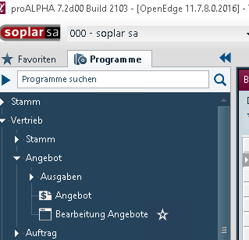
The program has the following options filter
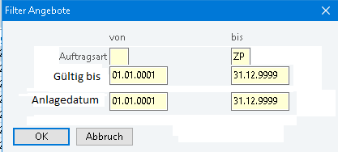

The English descriptions of the labels are:
Order
TypeValid
tocreated
คำอธิบายภาษาอังกฤษของป้ายกำกับมีดังนี้: ลำดับ ประเภทถูกต้อง ที่จะสร้าง
The filter has the following default values:
Order Category: First available order category in the master files - Last Available Order Category in the master files. All order categories
Valid to: 01/01/0001 - 12/31/9999
Creation date: 01/01/0001 - 12/31/9999
ตัวกรองมีค่าเริ่มต้นดังต่อไปนี้:
หมวดหมู่คำสั่งซื้อ: หมวดหมู่คำสั่งซื้อแรกที่มีอยู่ในไฟล์หลัก - หมวดหมู่คำสั่งซื้อสุดท้ายที่มีอยู่ในไฟล์หลัก หมวดหมู่คำสั่งซื้อทั้งหมด
ใช้ได้ถึง: 01/01/0001 - 12/31/9999
วันที่สร้าง: 01/01/0001 - 12/31/9999

During the execution, all quotes which correspond to the filter criteria and for which the document status is "Open" are archived. A document is only considered "open" if there is no sequential document yet.
The document for archiving must not have been adopted into a sequential document, not even partially.
เมื่อดำเนินการกระบวนการนี้ ใบเสนอราคาทั้งหมดที่ตรงตามเกณฑ์ตัวกรองและมีสถานะเอกสารเป็น "เปิด" จะถูกเก็บถาวร เอกสารจะถือว่า "เปิด" เท่านั้นตราบใดที่ไม่มีเอกสารติดตามผล เอกสารที่จะเก็บถาวรจะต้องไม่ถูกโอนแม้เพียงบางส่วนไปยังเอกสารติดตามผล
Examples for marking "Open":
Example of a quote to be archived since no sequential documents (from Test2):
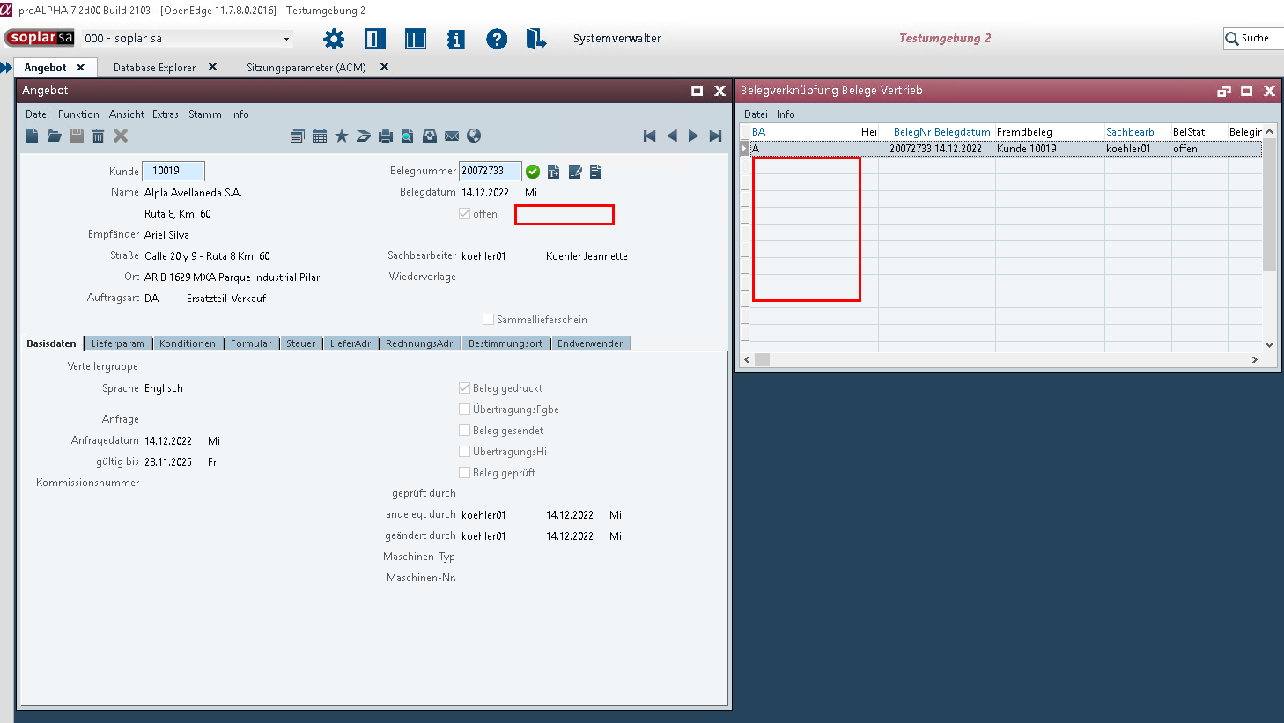
ตัวอย่างข้อความอ้างอิงที่ควรเก็บถาวร เนื่องจากไม่มีเอกสารเพิ่มเติมใดๆ
Example of a quote not to be archived since sequential documents (from Test2):
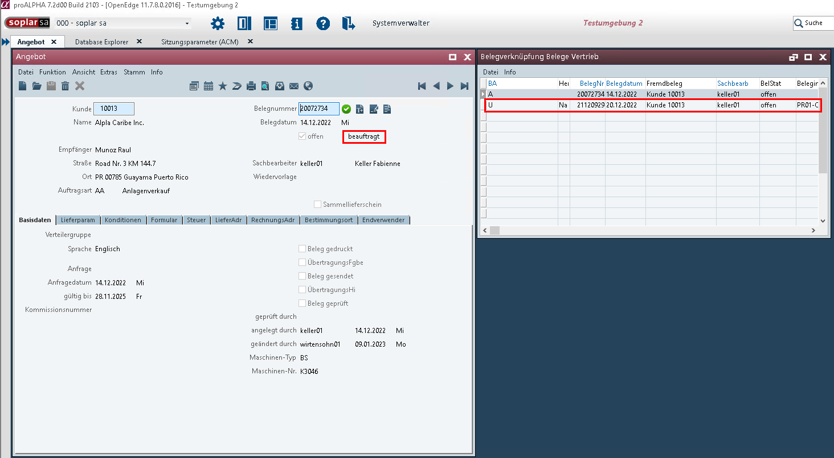
ตัวอย่างข้อความอ้างอิงซึ่งไม่ควรเก็บไว้ในคลังข้อมูลเนื่องจากเกี่ยวข้องกับเอกสารที่เกี่ยวข้องในภายหลัง
The program can be executed separately in each company. It can also be executed via ToDo management.
โปรแกรมนี้สามารถใช้งานแยกกันในแต่ละบริษัทได้ นอกจากนี้ยังสามารถใช้งานผ่านระบบจัดการรายการสิ่งที่ต้องทำ (ToDo management) ได้อีกด้วย

data model

Output

differentiation
The customization refers to the tables, fields and programs mentioned above.
This specification does not automatically make functional expansions in adjacent modules of the proALPHA environment, such as DMS, Analyzers, reports and forms. The proALPHA help is not automatically expanded either.
Changes to adjacent modules / programs have to be described and defined in the specifications.

Test cases
The specified test cases map the adaptation described here and are the basis for the acceptance of the software.

Opening the program and archiving quotes
Pct. | description | Expected result | test data
 | The Archiving Quotes program can be opened in "Sales" >> "Quotes" | Filter Dialog Starts
 | Test result (including screenshots)
 | Entering a selection and "OK" | The corresponding documents (according to selection and not open) are archived
 | Test result (including screenshots)
 | Test result (including screenshots)

Automation in task management
Pct. | description | Expected result | test data
 | The program can be integrated into the ToDo list in all companies
 | Test result (including screenshots)
 | The corresponding quotes are archived via ToDo.
 | Test result (including screenshots)
 | Test result (including screenshots)

Technical design

<template for section>

surface

business logic

data model

Final provisions
This specification forms the basis for customer-specific expansions of the standard software proALPHA®.
The customer-specific expansions only include the category defined in this specification. Functionality beyond this scope is not provided.
Unless expressly agreed otherwise, the customer-specific expansions are only created in German: Programs, program parts or data are not translated into other languages. This also applies to the languages supported by proALPHA® in the standard version.
The customer-specific expansions are carefully tested before they are delivered. However, for technical reasons, it is not possible to perform the test under the same conditions and with the same data as the customer. It is therefore recommended to carefully check the functions after they have been delivered in the real system environment.
The customer is aware that variances in display details or handling may be required for transferring the functions defined in this specification to new versions of proALPHA®. This specification also remains valid in this case, provided that there is a maintenance agreement for the customer-specific expansions defined in this specification and that no changes to the functionality have to be agreed.
This specification documents the customer-specific expansions. No other documentation than the service specification contained in this specification is to be provided. Questions about customer-specific expansions are accepted and forwarded by the hotline.
By signing on page 1 you confirm:
that the specification is accepted in this version and becomes part of the contract,
that this specification defines the scope of functions of the software to be created and that there are no side agreements regarding the functionality.

appendix

table of figures
No entries for an image directory could be found.

table index
TOC \h \z \c "Tabelle" No entries for an image directory could be found.

Change history
Doc. -  version | Date | specialist | initiator | Chapter | description
<X.Y> |  | Lars Garth | Christof Wüst | All | Initial new entry

